## Proper Tech

## Summary

At Proper tech we specialize in providing cutting edge computer components. We pride ourselves on our extensive library of high-quality gaming components. Customer can build their ideal PC to suit their gaming needs. We aim to accommodate all gamers, whether you are looking for a high-end gaming rig, or a starter PC that can still give you the edge that you are looking for.

**LINK FOR THE SERVER HERE:** <http://35.185.242.35/shop/index.jsp>

## Project Features List

|  |  |  |  |  |
| --- | --- | --- | --- | --- |
| **Final Overall System Features** | **Category** | **Possible Points** | **Points** | **Comments / Code Files** |
| **Documentation (10 total points)** | | | | |
| Executive Summary (up to 1 page) | Core | 2 |  |  |
| System Features (2 pages) | Core | 2 |  |  |
| Walkthrough with screenshots (up to 10 pages) | Core | 6 |  |  |
|  | | | | |
| **Hosting (10 total points)** | | | | |
| Running on cloud server | Advanced | 10 |  | <http://35.185.242.35/shop/index.jsp> |
|  | | | | |
| **Main/Home Page (up to 14 total points)** | | | | |
| Search for a product by name | Core | 1 |  |  |
|  |  |  |  |  |
| List products (by search/browse) | Core | 1 |  |  |
| List products with image | Core | 1 |  |  |
| Page header with menu | Basic | 1 |  |  |
| Page header shows current logged in user | Basic | 1 |  |  |
|  |  |  |  |  |
| Improved UI (user-friendly, images, etc.) | Basic | 2? |  |  |
|  | | | | |
| **Shopping Cart (up to 8 total points)** | | | | |
| Add to shopping cart | Core | 1 |  |  |
| View shopping cart | Core | 1 |  |  |
|  | | | | |
| **Checkout (up to 9 total points)** | | | | |
| Checkout with customer id | Core | 1 |  |  |
| Checkout with payment/shipment info | Basic | 2 |  |  |
| Checkout with data validation | Basic | 2 |  |  |
|  | | | | |
| **Product Detail Page (up to 2 total points)** | | | | |
| Product detail page and item description | Core | 1 |  |  |
| Product detail has an image from database | Core | 1 |  |  |
|  | | | | |

|  |  |  |  |  |
| --- | --- | --- | --- | --- |
| **User Accounts/Login (up to 12 total points)** | | | | |
| Create user account page | Basic | 2 |  |  |
| Create account with data validation | Basic | 2 |  |  |
| Edit user account info (address, password) | Basic | 2 |  |  |
| Login/logout | Core | 1 |  |  |
|  |  |  |  |  |
| Page listing all orders for user | Core | 1 |  |  |
|  | | | | |
| **Product Reviews (up to 5 total points)** | | | | |
| Ability to enter a review on a product | Basic | 2 |  |  |
| Display product review on product detail page | Basic | 1 |  |  |
| Restrict to one review per user on item purchased | Advanced | 2 |  |  |
|  |  |  |  |  |
| **Warehouse/Inventory (Up to 5 total points)** |  |  |  |  |
| Display Item inventory by store/warehouse | Basic | 2 |  |  |
| Edit item inventory by store/warehouse | Advanced | 3 |  |  |
|  |  |  |  |  |
| **Administrator Portal (up to 19 total points)** |  |  |  |  |
| Secured by login | Core | 1 |  |  |
| List all customers | Core | 1 |  |  |
| List report showing total sales/orders | Core | 1 |  |  |
|  |  |  |  |  |
| Add new product | Basic | 2 |  |  |
| Update/delete product | Basic | 2 |  |  |
|  |  |  |  |  |
| **Database System/General** |  |  |  |  |
| User interface and navigation/usability |  | Up to 5 |  |  |
| Use AJAX for some pages |  | Up to 5 |  | editProduct.jsp |
| **Total: (out of 50 with maximum of 10 bonus marks. i.e. 60 points out of 50 is max.)** |  |  |  |  |

## Walkthrough

For the walkthrough we will be discussing how to navigate the store, as well as highlighting some of the key features the website has to offer.

## Homepage

The homepage offers a variety of options for the user to choose from.

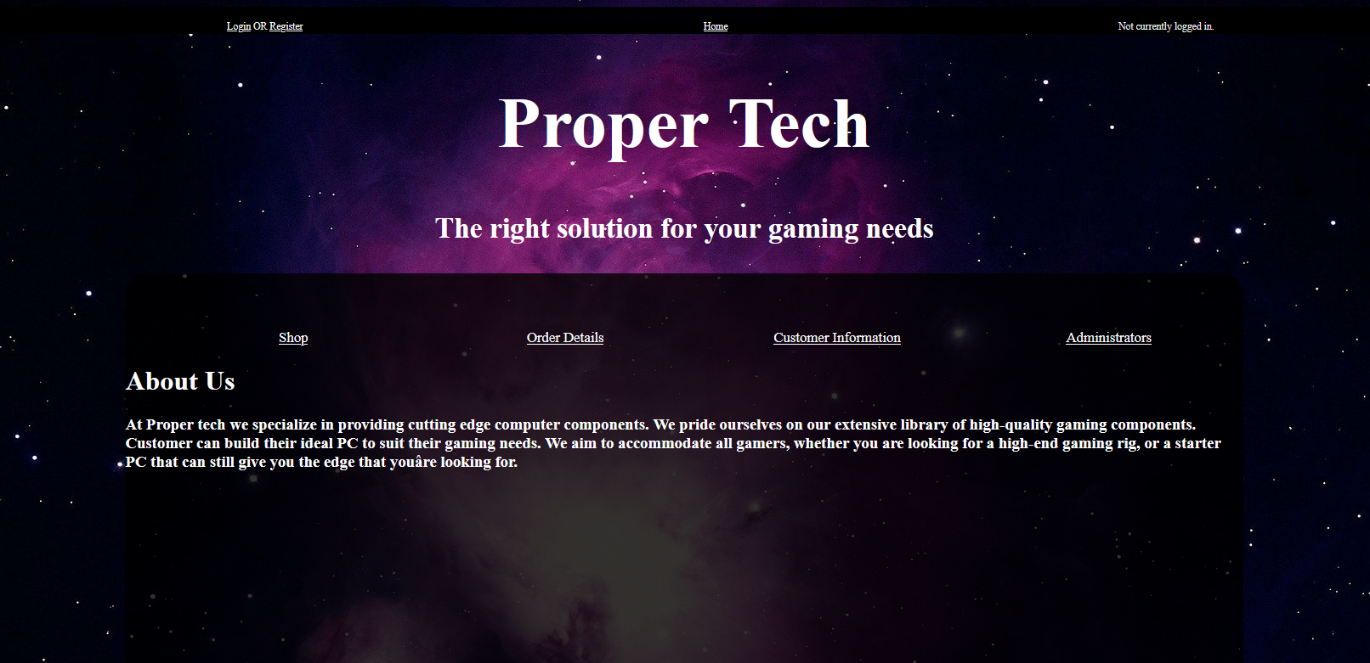

The homepage offers a brief description of our company.

## Header

The header allows users to login or to register for an account. It also allows the user to navigate back to the homepage at any time. And finally, it indicates to the user whether they are logged in or not.

# Not Logged In:



# Logged In:



When the user is logged in, the navbar will switch the prompted values and indicate who is logged in, as well as feature an option to logout.

## Login Page

The login page uses validation to provide feedback to the user, as well as to properly log users into their accounts.

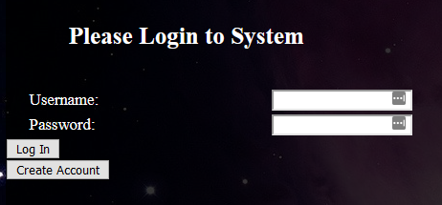

This screenshot depicts what a possible error message may look like

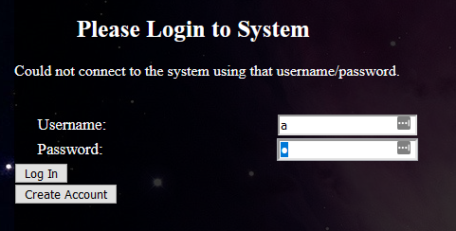

## Create Account

If a user does not have an account, they can create one via the create account page.

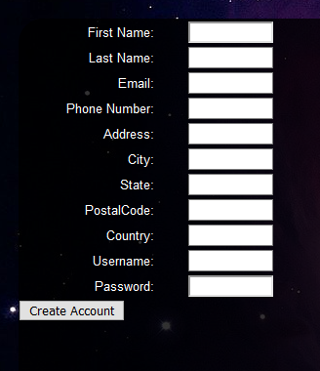

### Shop

Users can click on the product to get more information on it, as well, a user can immediately add a product to their cart by clicking on the button. The products page offers a search navigation bar.

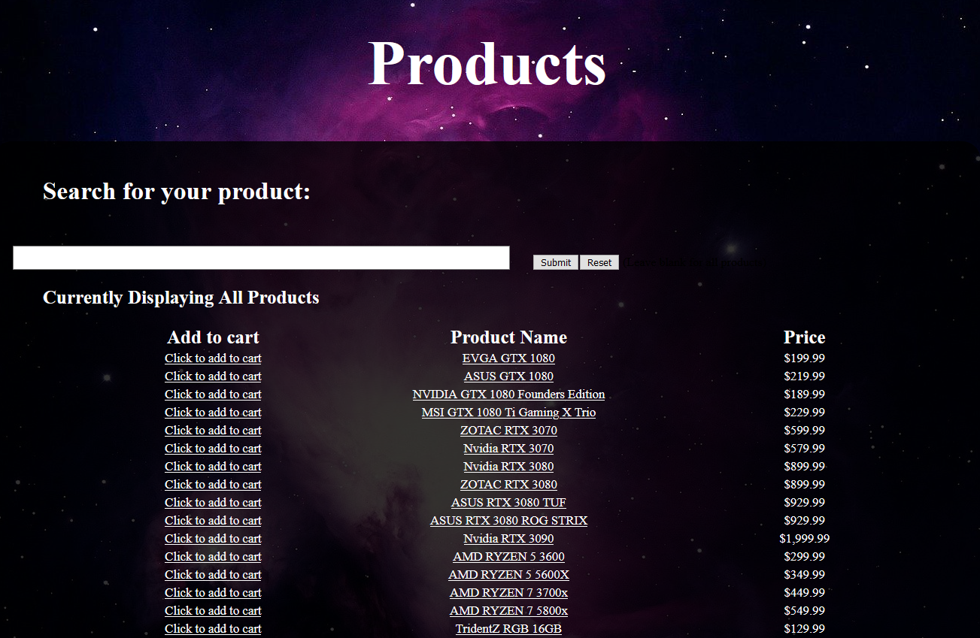

## Product

The Product page lists details pertaining to a specific product, as well a user can add the item to their cart from this menu or continue looking at other offered products.

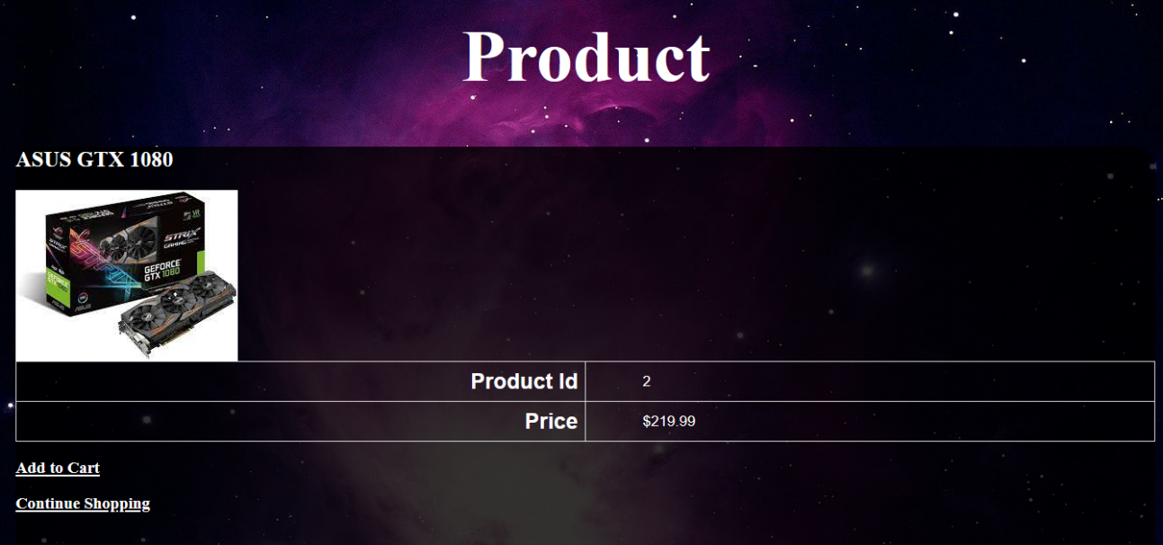

## Product Reviews

Users can leave their feedback on the items they have purchased for other users to see.

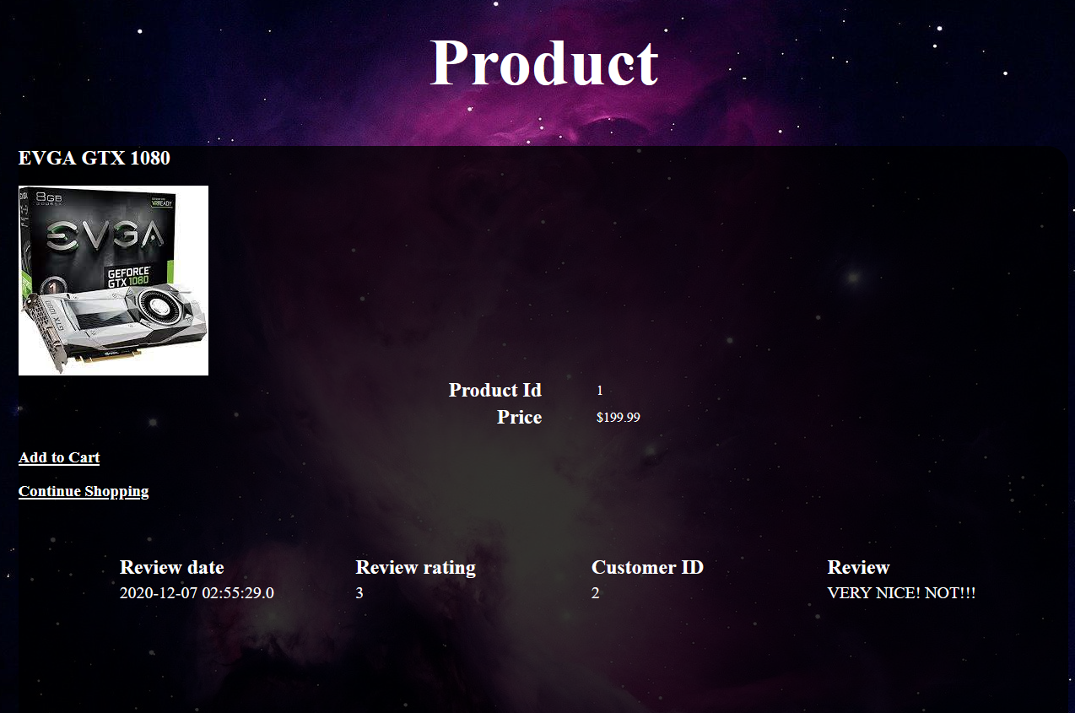

## Shopping cart

Once a user has found an item they would like, they can add the item to their shopping cart. The cart automatically updates the total price if there are other products in their cart.

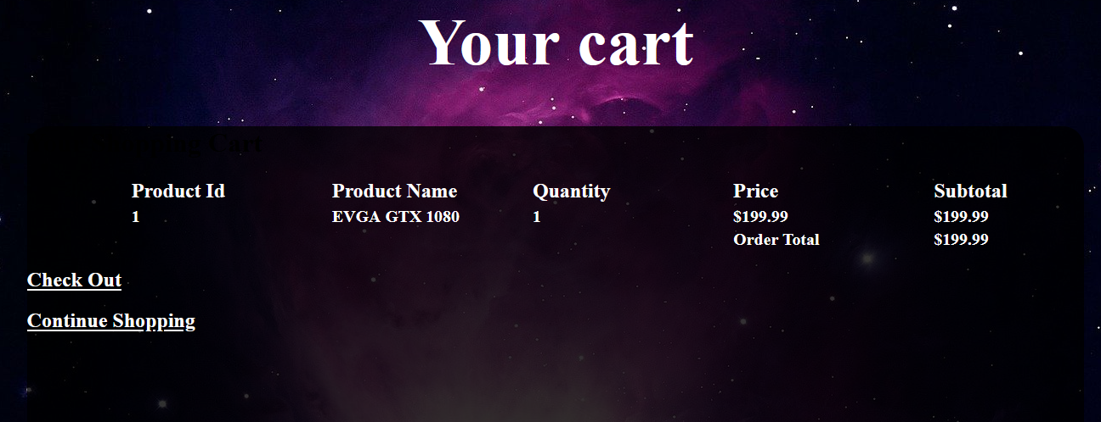

## Order Summary

Once a user has authorized their purchase, they will be prompted with the information pertaining to their order.

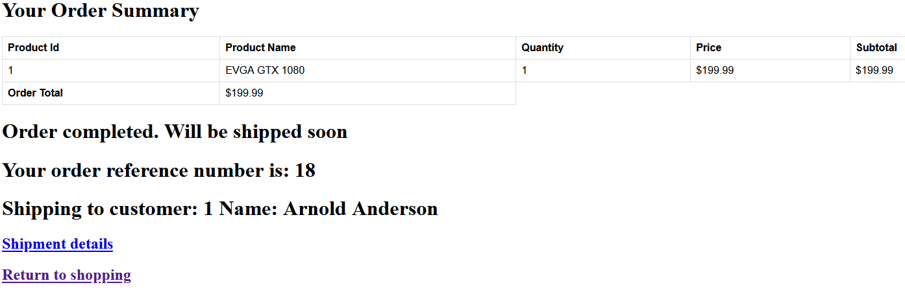

## Shipment

The shipments page confirms the shipment of a product

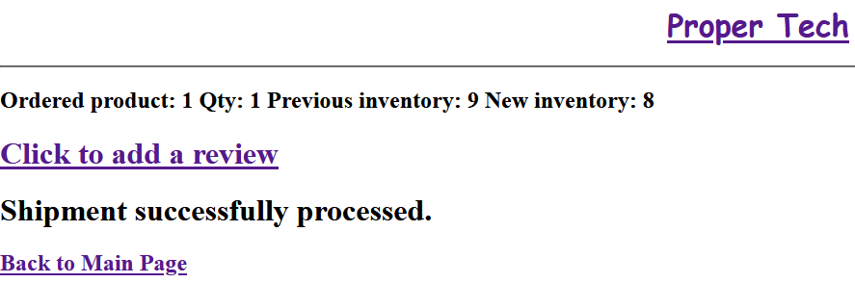

## Review Page

Users who have purchased an item can rate and leave a detailed description of their overall satisfaction with their product.

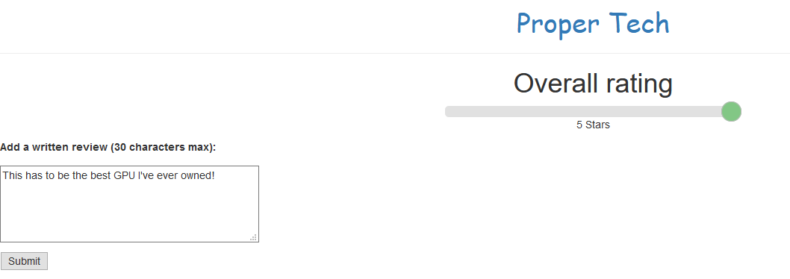

## Order Details

Shows all orders ever made

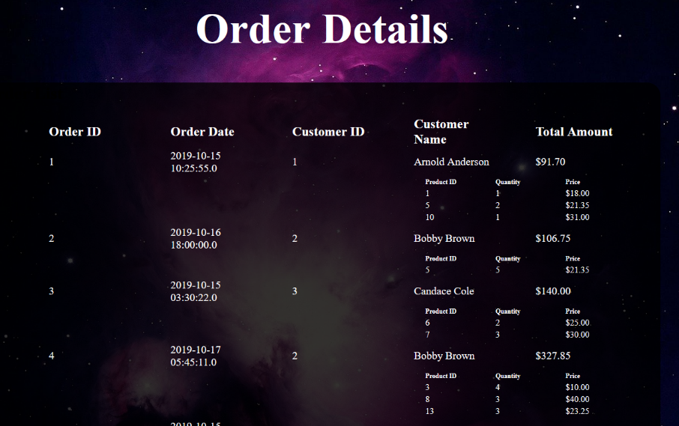

## Customer Information

This page is only accessible for users who are logged in. It displays all of the users information.

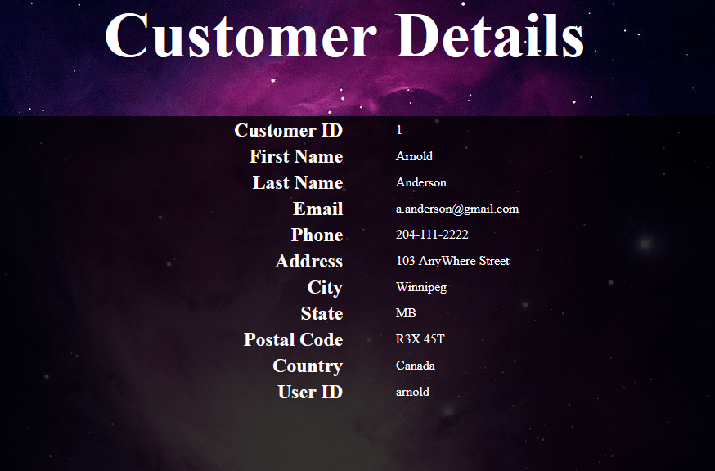

## Inventory

The Inventory page allows users to display inventory items by warehouse as well as to edit them.

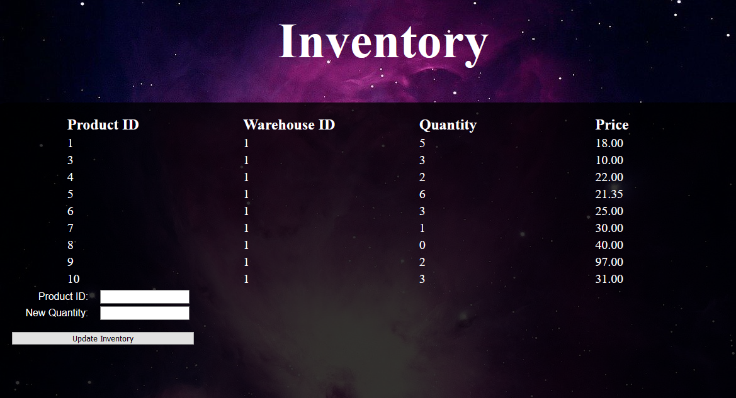

# Inventory After Updating Quantity:

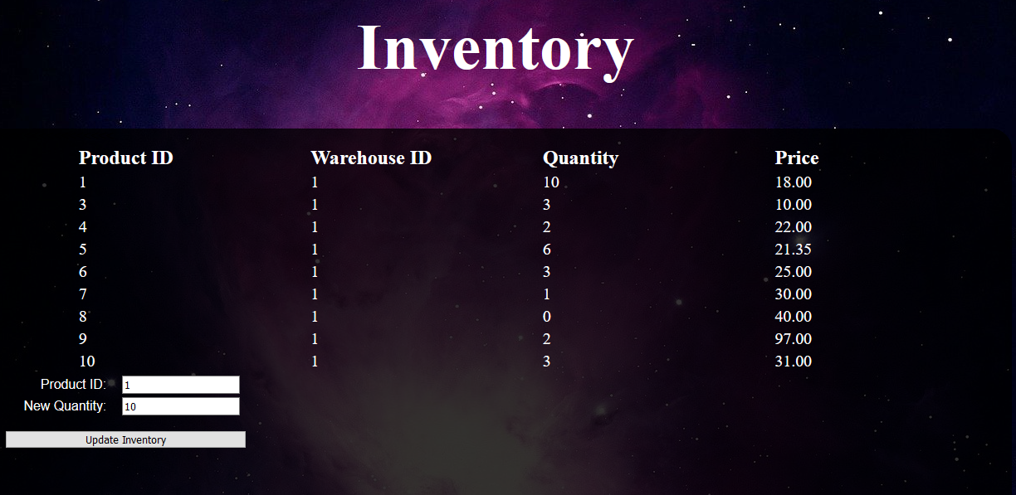

## Admin Page

The admin page is secured by login, lists all customers, lists all sales, and allows the user to add/modify/delete products

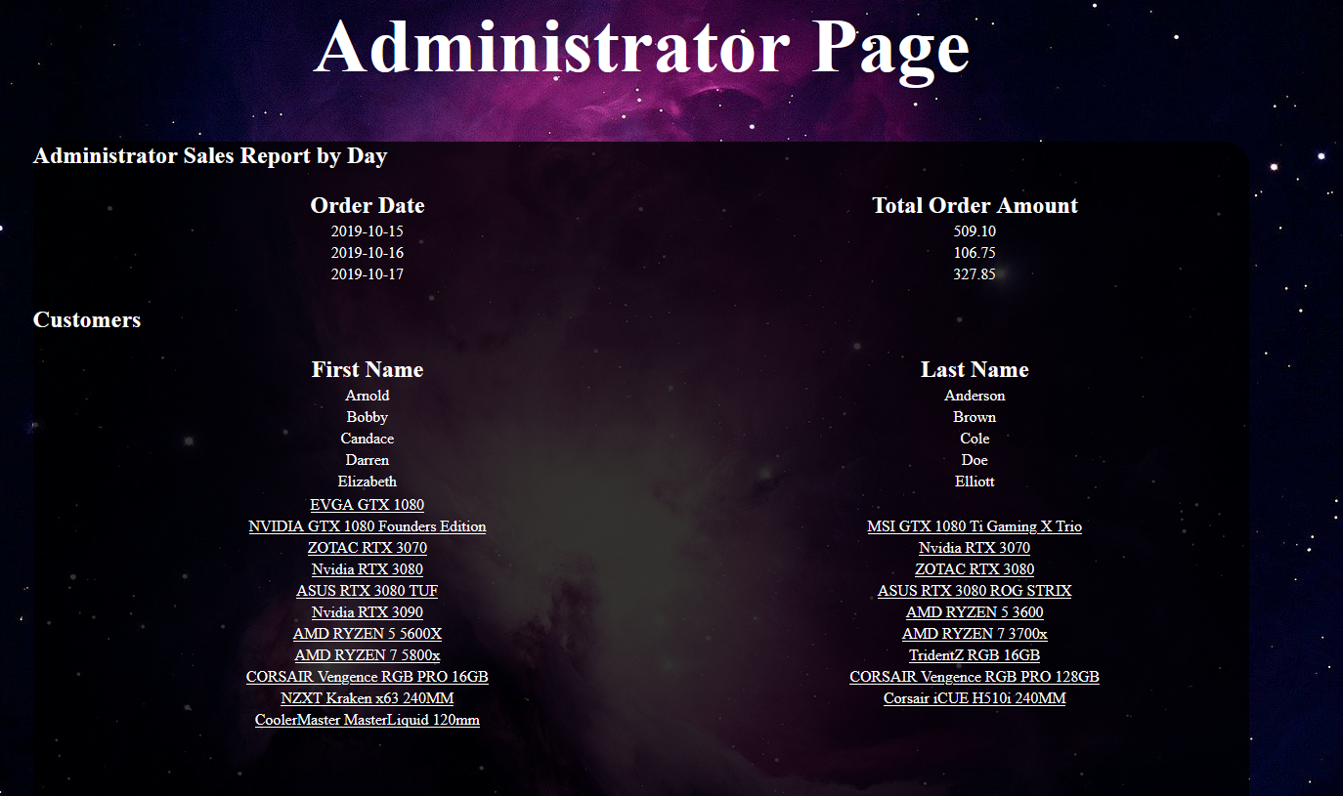

## Edit Product

This page allows administrators to modify, add, and delete products.

